Paul Collado
CSC-208-60
Oct 04, 2010

ColladoCh04Page195

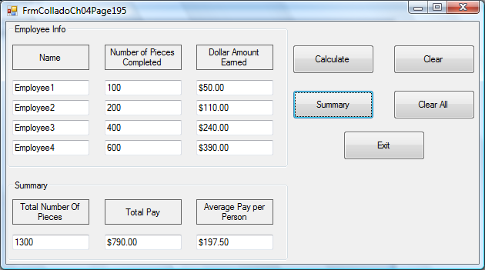

Public Class FrmColladoCh04Page195
Dim DollarEarned1 As Decimal
Dim DollarEarned2 As Decimal
Dim DollarEarned3 As Decimal
Dim DollarEarned4 As Decimal

Dim PriceperPiece1 As Decimal
Dim PriceperPiece2 As Decimal
Dim PriceperPiece3 As Decimal
Dim PriceperPiece4 As Decimal

Dim pieces1 As Integer
Dim pieces2 As Integer
Dim pieces3 As Integer
Dim pieces4 As Integer

Private Sub BtnCalculate_Click(ByVal sender As System.Object, ByVal e As System.EventArgs) Handles BtnCalculate.Click

If (Me.TxtEmployee1.Text = "" Or Me.TxtEmployee2.Text = "" _
Or Me.TxtEmployee3.Text = "" Or Me.TxtEmployee4.Text = "" _
Or Me.TxtNumOfPieces1.Text = "" Or Me.TxtNumOfPieces2.Text = "" _
Or Me.TxtNumOfPieces3.Text = "" Or Me.TxtNumOfPieces4.Text = "") Then
Try
Me.TxtEmployee1.Text = "" Or Me.TxtEmployee2.Text = "" _
Or Me.TxtEmployee3.Text = "" Or Me.TxtEmployee4.Text = "" _
Or Me.TxtNumOfPieces1.Text = "" Or Me.TxtNumOfPieces2.Text = "" _
Or Me.TxtNumOfPieces3.Text = "" Or Me.TxtNumOfPieces4.Text = ""

Catch ex As Exception
MessageBox.Show("Please fill all Names and all Number Of Pieces Completed", "DATA ENTRY ERROR!")

End Try
Else
pieces1 = Val(Me.TxtNumOfPieces1.Text)
pieces2 = Val(Me.TxtNumOfPieces2.Text)
pieces3 = Val(Me.TxtNumOfPieces3.Text)
pieces4 = Val(Me.TxtNumOfPieces4.Text)

If (pieces1 < 200) Then
PriceperPiece1 = 0.5
ElseIf (pieces1 > 199 And pieces1 < 400) Then
PriceperPiece1 = 0.55
ElseIf (pieces1 > 399 And pieces1 < 600) Then
PriceperPiece1 = 0.6
ElseIf (pieces1 > 599) Then
PriceperPiece1 = 0.65
End If
If (pieces2 < 200) Then
PriceperPiece2 = 0.5
ElseIf (pieces2 > 199 And pieces2 < 400) Then
PriceperPiece2 = 0.55
ElseIf (pieces2 > 399 And pieces2 < 600) Then
PriceperPiece2 = 0.6
ElseIf (pieces2 > 599) Then
PriceperPiece2 = 0.65
End If
If (pieces3 < 200) Then
PriceperPiece3 = 0.5
ElseIf (pieces3 > 199 And pieces3 < 400) Then
PriceperPiece3 = 0.55
ElseIf (pieces3 > 399 And pieces3 < 600) Then
PriceperPiece3 = 0.6
ElseIf (pieces3 > 599) Then
PriceperPiece3 = 0.65
End If
If (pieces4 < 200) Then
PriceperPiece4 = 0.5
ElseIf (pieces4 > 199 And pieces4 < 400) Then
PriceperPiece4 = 0.55
ElseIf (pieces4 > 399 And pieces4 < 600) Then
PriceperPiece4 = 0.6
ElseIf (pieces4 > 599) Then
PriceperPiece4 = 0.65
End If

DollarEarned1 = pieces1 * PriceperPiece1
DollarEarned2 = pieces2 * PriceperPiece2
DollarEarned3 = pieces3 * PriceperPiece3
DollarEarned4 = pieces4 * PriceperPiece4

Me.TxtDollarEarned1.Text = FormatCurrency(DollarEarned1)
Me.TxtDollarEarned2.Text = FormatCurrency(DollarEarned2)
Me.TxtDollarEarned3.Text = FormatCurrency(DollarEarned3)
Me.TxtDollarEarned4.Text = FormatCurrency(DollarEarned4)

BtnSummary.Enabled = True
End If

End Sub

Private Sub BtnSummary_Click(ByVal sender As System.Object, ByVal e As System.EventArgs) Handles BtnSummary.Click
Dim TotalPieces As Integer
Dim TotalEarned As Decimal
Dim Average As Decimal

TotalPieces = pieces1 + pieces2 + pieces3 + pieces4
Me.TxtTotalNumOfPieces.Text = Totalpieces

TotalEarned = DollarEarned1 + DollarEarned2 + DollarEarned3 + DollarEarned4
Me.TxtTotalPay.Text = FormatCurrency(TotalEarned)

Average = TotalEarned / 4
Me.TxtAverage.Text = FormatCurrency(Average)

End Sub

Private Sub BtnClear_Click(ByVal sender As System.Object, ByVal e As System.EventArgs) Handles BtnClear.Click
Me.TxtEmployee1.Clear()
Me.TxtEmployee2.Clear()
Me.TxtEmployee3.Clear()
Me.TxtEmployee4.Clear()
Me.TxtNumOfPieces1.Clear()
Me.TxtNumOfPieces2.Clear()
Me.TxtNumOfPieces3.Clear()
Me.TxtNumOfPieces4.Clear()
Me.TxtDollarEarned1.Clear()
Me.TxtDollarEarned2.Clear()
Me.TxtDollarEarned3.Clear()
Me.TxtDollarEarned4.Clear()

End Sub

Private Sub BtnClearAll_Click(ByVal sender As System.Object, ByVal e As System.EventArgs) Handles BtnClearAll.Click
Dim button As System.Windows.Forms.DialogResult
button = MessageBox.Show("Clear the Summary results?", "Clear Summary", _
MessageBoxButtons.YesNo, MessageBoxIcon.Question)

If button = System.Windows.Forms.DialogResult.Yes Then
Me.TxtTotalNumOfPieces.Clear()
Me.TxtTotalPay.Clear()
Me.TxtAverage.Clear()
End If
End Sub

Private Sub BtnExit_Click(ByVal sender As System.Object, ByVal e As System.EventArgs) Handles BtnExit.Click
Me.Close()
End Sub
End Class

